Project - 01

create a serverless image processing application that automatically resizes and optimizes images uploaded to an amazon s3 bucket.

Documentation:-

Step 1: Log in to AWS Management Console:
  - Open AWS Management Console.
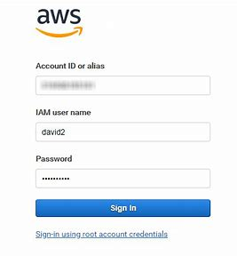

Serverless Image Processing Flow:

- User uploads a file to the source S3 bucket (which is used for storing uploaded images)
- When the image is uploaded to a source S3 bucket, it triggers an event which invokes the Lambda function. The lambda function processes the image.
- Processed image is stored in the destination S3 bucket.
- The processed image is requested by the user.

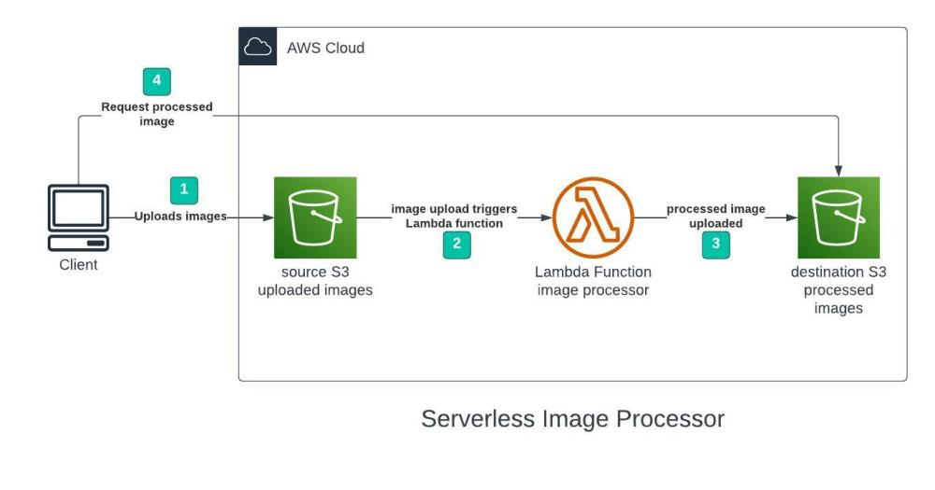

Step 2: Create an S3 Bucket

We will use two S3 buckets:

1. source Bucket: For storing uploaded images.
2. destination Bucket: For storing processed images.

Navigate to S3 Service:
In the search bar, type S3 and select the S3 service.
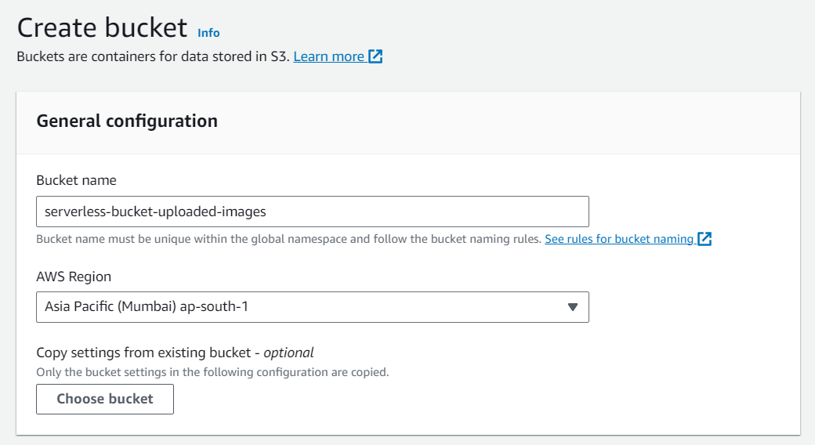
Create a New Bucket:
  - Click on Create bucket.
2. Provide a unique bucket name (e.g., my-website-bucket).
3. Choose the appropriate AWS region.
4. Leave the default settings and click Create bucket.
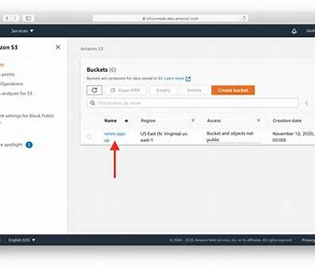

Step 3 – Creating Lambda function

- Go to AWS Lambda console.
- Navigate to Functions section.
- Click Create Function and name it “ImageProcessing”
- Select runtime as “NodeJS 16.x” and architecture as “x86_64”. Leave all other settings as default.

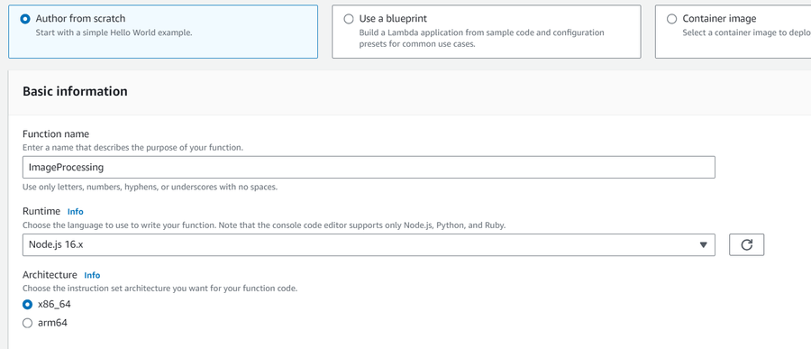

- Now go-to Code and upload code.(ex. Pyhton 3.8, Node.js16.x) and this code is upload only .zip file(like function.zip)

Node.js 16.x code:-

const sharp = require("sharp");
const path = require("path");
const AWS = require("aws-sdk");

// Set the REGION
AWS.config.update({
region: "ap-south-1",
});
const s3 = new AWS.S3();
const processedImageBucket = "serverless-bucket-processed-images";

// This Lambda function is attached to an S3 bucket. When any object is added in the S3
// bucket this handler will be called. When an image file is added in the S3 bucket, this function
// creates a square thumbnail of 300px x 300px size and it also creates a cover photo of
// 800px x 800px size. It then stores the thumbnail and coverphotos back to another S3 bucket
// at the same location as the original image file.
exports.handler = async (event, context, callback) => {
console.log("An object was added to S3 bucket", JSON.stringify(event));
let records = event.Records;
// Each record represents one object in S3. There can be multiple
// objects added to our bucket at a time. So multiple records can be there
// How many records do we have? Each record represent one object in S3
let size = records.length;

for (let index = 0; index < size; index++) {
let record = records[index];
console.log("Record: ", record);
// Extract the file name, path and extension
let fileName = path.parse(record.s3.object.key).name;
let filePath = path.parse(record.s3.object.key).dir;
let fileExt = path.parse(record.s3.object.key).ext;

console.log("filePath:" + filePath + ", fileName:" + fileName + ", fileExt:" + fileExt);

// Read the image object that was added to the S3 bucket
let imageObjectParam = {
Bucket: record.s3.bucket.name,
Key: record.s3.object.key,
};

let imageObject = await s3.getObject(imageObjectParam).promise();
// Use sharp to create a 300px x 300px thumbnail
// withMetadata() keeps the header info so rendering engine can read
// orientation properly.
let resized_thumbnail = await sharp(imageObject.Body)
.resize({
width: 300,
height: 300,
fit: sharp.fit.cover,
})
.withMetadata()
.toBuffer();
console.log("thumbnail image created");

// Use sharp to create a 800px x 800px coverphoto
let resized_coverphoto = await sharp(imageObject.Body)
.resize({
width: 800,
height: 800,
fit: sharp.fit.cover,
})
.withMetadata()
.toBuffer();
console.log("coverphoto image created");

// The processed images are written to serverless-image-processing-bucket.
let thumbnailImageParam = {
Body: resized_thumbnail,
Bucket: processedImageBucket,
Key: fileName + "_thumbnail" + fileExt,
CacheControl: "max-age=3600",
ContentType: "image/" + fileExt.substring(1),
};
let result1 = await s3.putObject(thumbnailImageParam).promise();
console.log("thumbnail image uploaded:" + JSON.stringify(result1));

let coverphotoImageParam = {
Body: resized_coverphoto,
Bucket: processedImageBucket,
Key: fileName + "_coverphoto" + fileExt,
CacheControl: "max-age=3600",
ContentType: "image/" + fileExt.substring(1),
};
let result2 = await s3.putObject(coverphotoImageParam).promise();
console.log("coverphoto image uploaded:" + JSON.stringify(result2));
}
};

- Now go-to polices and create new polices in json and upload code.and code modify(like change bucket name place of source bucket and dest-bucket place use destination bucket).

Json code

{
"Version": "2012-10-17",
"Statement": [
{
"Effect": "Allow",
"Action": [
"logs:PutLogEvents",
"logs:CreateLogGroup",
"logs:CreateLogStream"
],
"Resource": "arn:aws:logs:*:*:*"
},
{
"Effect": "Allow",
"Action": ["s3:GetObject"],
"Resource": "arn:aws:s3:::BUCKET_NAME/*"
},
{
"Effect": "Allow",
"Action": ["s3:PutObject"],
"Resource": "arn:aws:s3:::DEST_BUCKET/*"
}
]
}

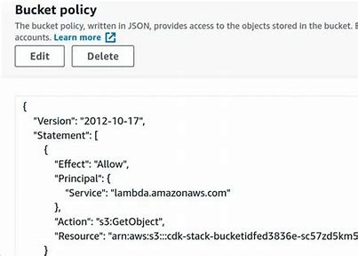
Click Next

- Now give the policy name and click create policy.

- Go-to the IAM and create a new role and select lambda and click next.

- Select policy click next.

- Give role name create role.

- And now select use an existing role in change default excution role and select our role and click create function.

- Add trigger

- Select s3

- Give source bucket in bucket option.

- Check acknowledge and further no change click add.

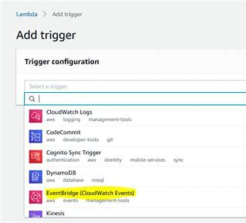

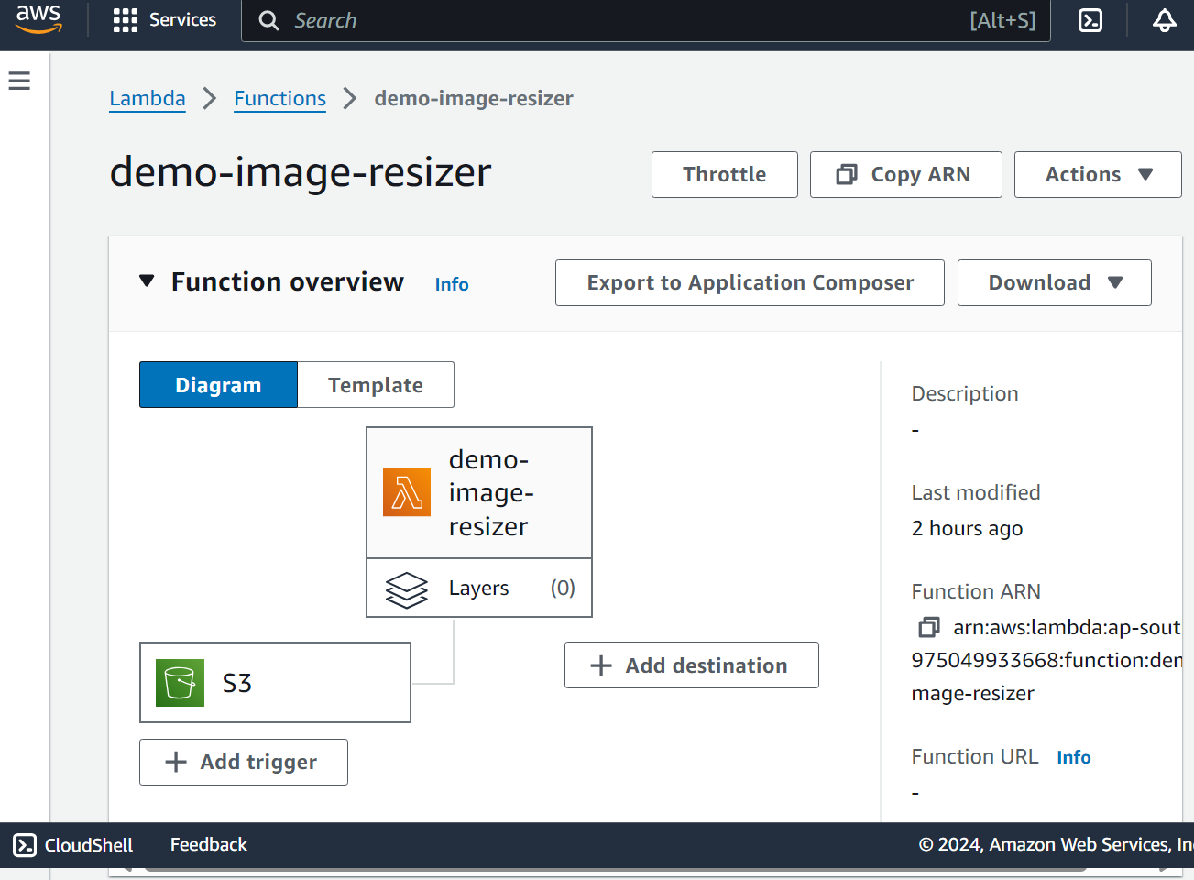

Environment Variable

- This option is available in configure section.

- Edit Environment Variable

- Key DEST_BUCKET and value your destination bucket.

- Save

- Now go-to the Test option and select s3-put option.(modify code source-bucket place of exemple-bucket and upload file are used in key).

- And Test it.

- Source bucket.

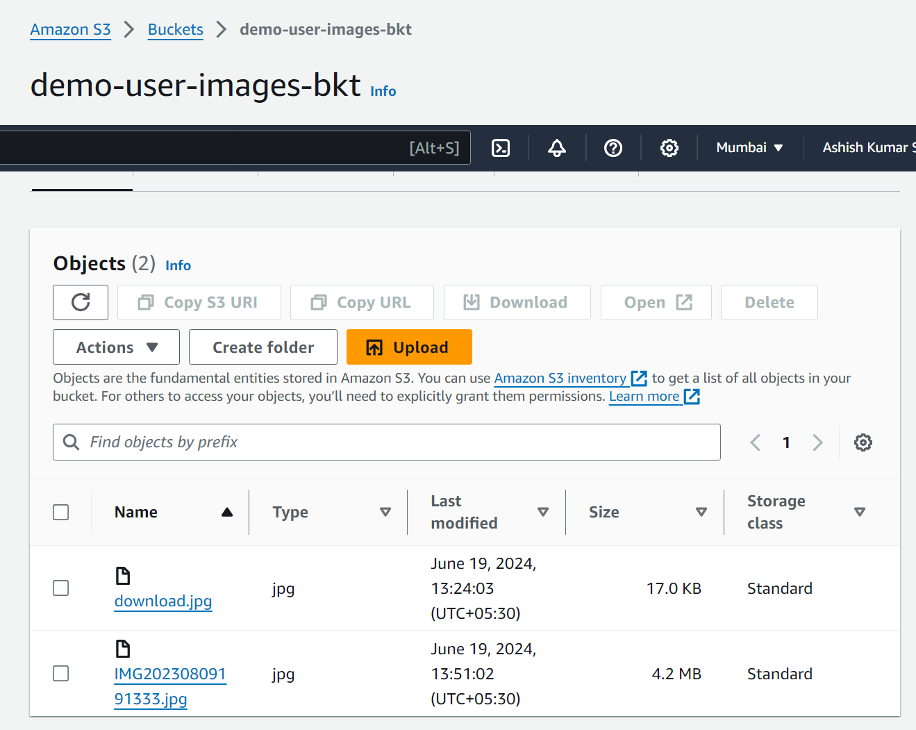

- Go-to the destination bucket and check your image are resize.

